**The cirrhosis ~ alcohol problem**

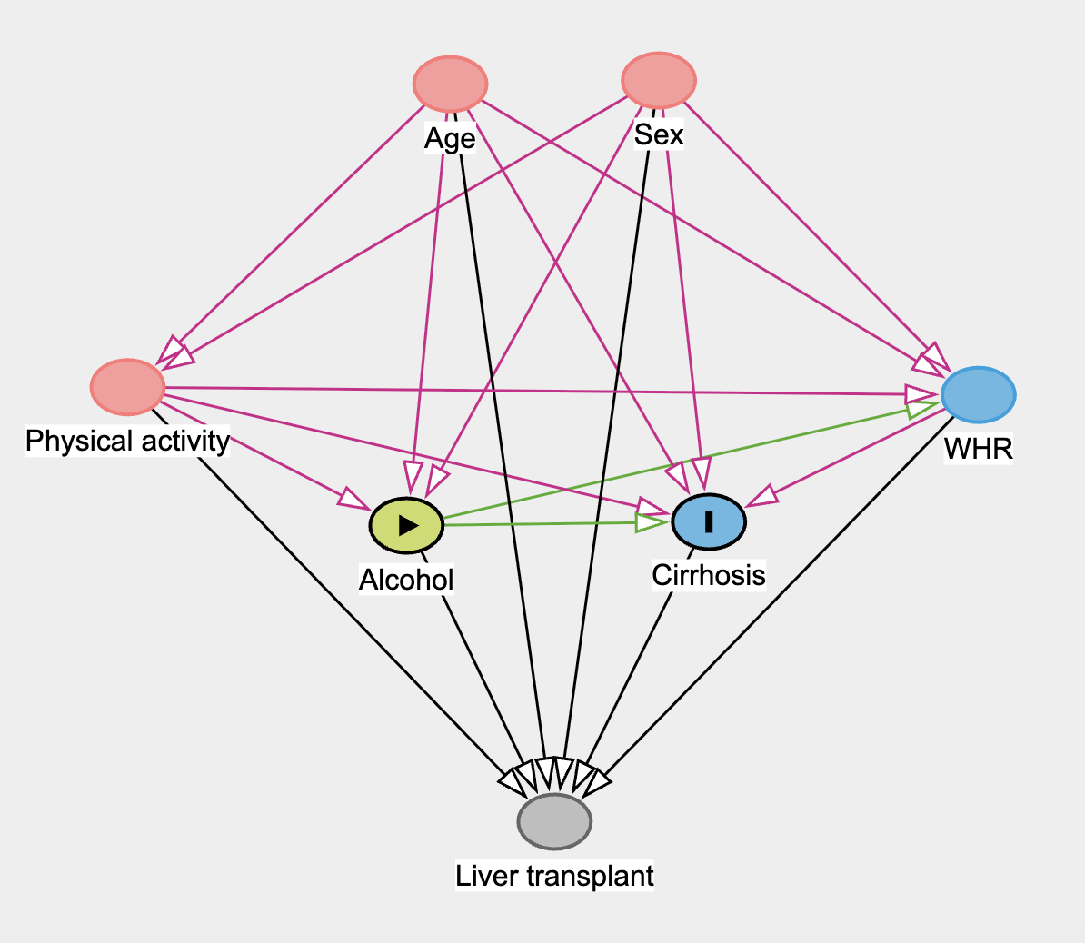

We believe that the relationships between the variables in our dataset are represented in the diagram above. Therefore for estimating the average total effect of alcohol on cirrhosis, we need to adjust our model to age, sex and physical activity.

We fitted a logistic regression model using Bambi:

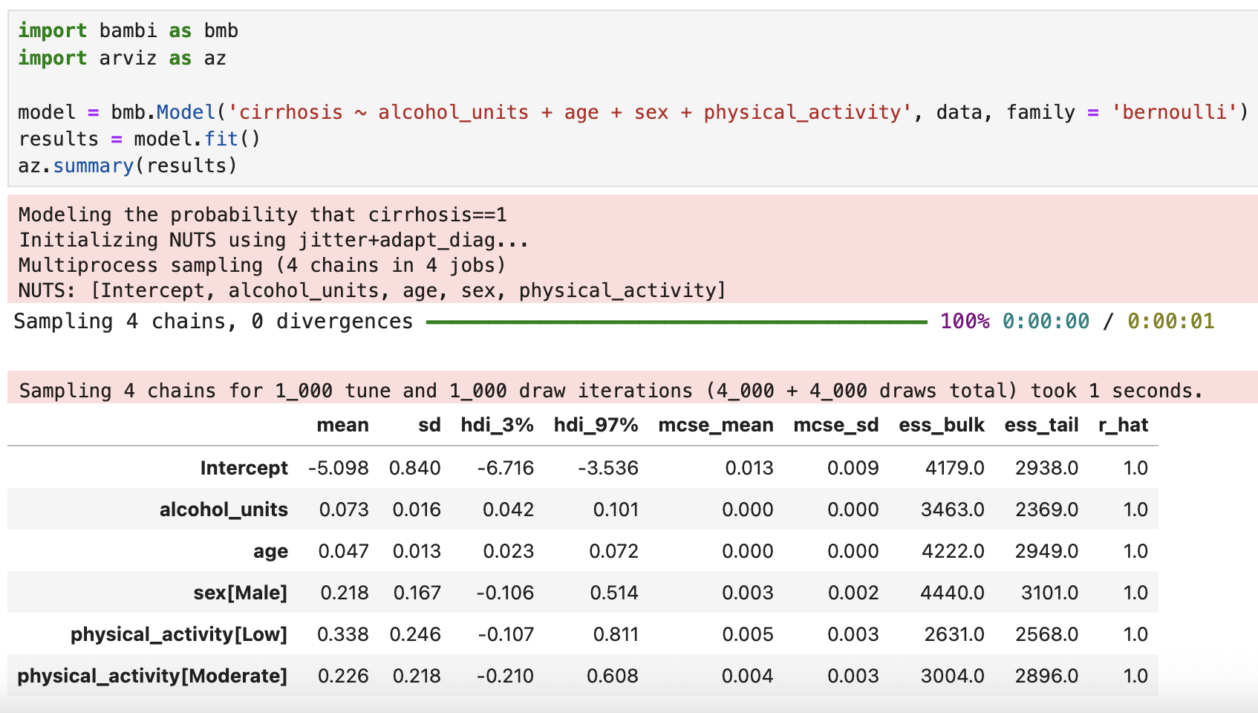

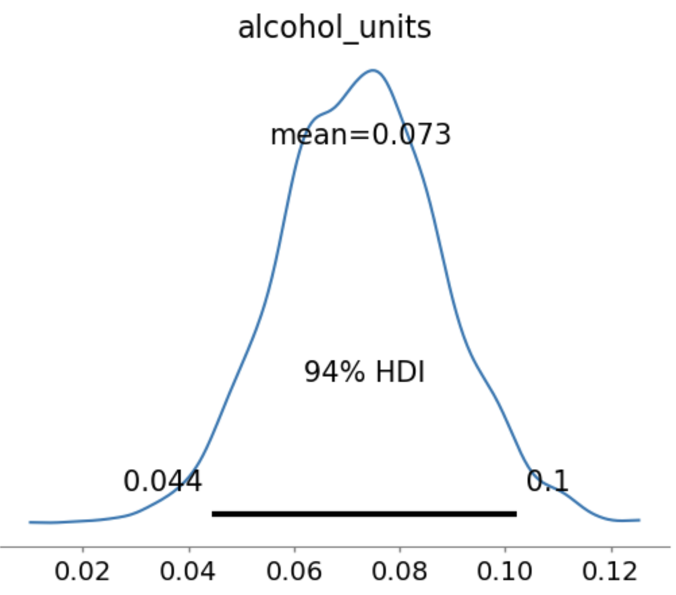

Since we fitted a logistic regression model, all coefficients need to be exponentiated to obtain the corresponding odds ratios. For alcohol consumption, the estimated odds ratio is exp(0.073) ≈ 1.076. This means that for each one-unit increase in weekly alcohol consumption, the odds of developing cirrhosis increase by 7.6%, assuming age, sex, and physical activity remain constant. The 94% highest density interval for this odds ratio ranges from exp(0.044) ≈ 1.045 to exp(0.1) ≈ 1.105, indicating that there is a 94% probability that the true odds ratio lies within this interval.